**Automation for SOW.**

**What?**

Need to automate the verifying of the documents.

The automation of different documents in phases. Total 3 Phase project

**Phase 1:**

1. PPt to Meghana with one Auto piolet plug-in.
2. This will include the automation of SOW only for EMEA region.
3. Suggesting the integration with SFS.

**Phase 2:**

If plugin is accepted.

1. Automation for Quote and Subcon SOW.
2. Comparison between SOW and Change Order

**Phase 3:**

1. Applying the logic for all regions for mutual benefit.

**WHY**

This would be time consuming and would help especially during quarter end.

These documents are in form of templates and are updated by respective resources.

The operation teamwork is to verify if the items in SOW with the item available in SFS.

If we have a short preview of these items, it will ease the job significantly.

Scrolling down is not a concern, but thereare multiple deals floating in at same time.

They need to be actioned asap always. I am talking of 7 to 15 bids in a day per PM. Catering approximately 30 – 40 Project requests. Such alarming situations are usually during q end.

For us to take any action we always need to verify with the SOW/Quote. It is a mandate.

We have observe our own PM getting wonky at times and sending wrong informatio

The SOW/Quote is main document to execute our project. Thus, we need to refer it all the time.

\

We need the preview of the main items listed below:

1. End-user Details
2. Partner Company details
3. Reseller/Disty details
4. Type of Deal
5. Fee Schedule.
6. Payment Terms

A check box will suffice to indicate that:

1. All the standard TnC’s are covered

**Here are the screen shots from SOW.**

End-user Details Partner Company details; Reseller/Disty details

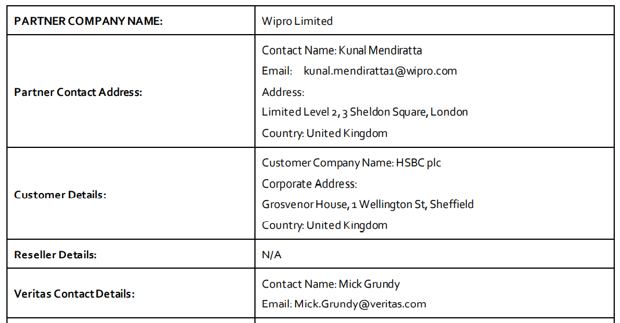

\

Type of Deal and Fee Schedule.

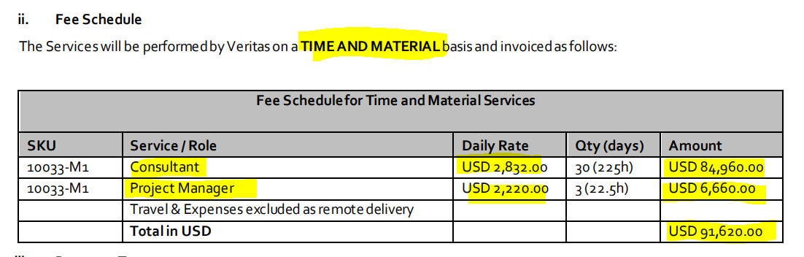

Payment terms:

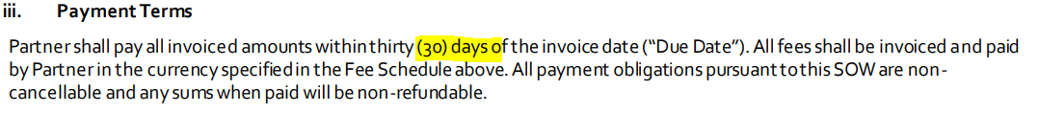

Veritas Terms and conditions are in main Clause E with sub clauses 1 to 12.

Last clause should be 12j.

**How**



 

Payment Terms

Deal Type

Reset

Milestones with Pricing/

T+M with Pricing

VSU Units

Standard TnC’s

Partner Name:

Contact Details and Address

Contact and Address

Re-seller/ Disty Name

Contact details and Address.

End-user Name:

Upload File